Knowledge Graph (KG) Component - Sharan's Documentation
This document explains, step-by-step, how the Knowledge Graph component of the LegalVision project was built. It starts from data extraction and structuring, continues with Neo4j setup, and ends with successful graph loading and verification. This guide assumes no prior experience with Neo4j.

1. Extracting and Structuring Data
1. Open the main data file: '30 generated data sets for six types deeds.docx'.
2. For each deed, copy its text (type, plan, parties, boundaries, etc.) and save it as a plain text file under data/raw.
3. Then, use the Python extraction script to convert those plain text files into structured JSON files. Each JSON represents one deed.
4. Save all generated JSON files (e.g., DEED_001.json to DEED_027.json) in the folder data/structured/.

2. Folder Structure
Ensure your project folder looks like this:
LegalVision/
├── data/
│ ├── raw/ → Original deed text files
│ ├── structured/ → JSON outputs from extraction
├── docs/ → Documentation, ontology
└── neo4j_load.py → Python script for Neo4j loading

3. Installing Dependencies
Use PowerShell or Terminal inside your project folder and install required libraries:
pip install neo4j python-docx python-dotenv

4. Setting up Neo4j Aura (Cloud Database)
1. Visit https://neo4j.com/cloud/platform/aura-graph-database/ and sign up.
2. Create a new free instance (AuraDB Free) named 'legalvision-db'.
3. Copy the connection details (URI, Username, Password).
4. Click 'Open with Neo4j Browser' to access the online Neo4j interface.
5. Confirm it works using the query: RETURN 'Connected to Neo4j Aura' AS Message;

5. Preparing the Neo4j Loader Script
The neo4j_load.py script reads each JSON and uploads entities into Neo4j.
It creates nodes for Instruments, Persons, Property Parcels, and Plans, and relationships between them.
The script also handles missing fields gracefully.
Save this script as neo4j_load.py in your root folder.

6. Running the Loader
Run the following command in PowerShell:
python neo4j_load.py
If successful, you’ll see messages like:
Found 27 JSON files in data/structured
Loaded DEED_001.json sale_transfer UNKNOWN-1
... Done.

7. Verifying Data in Neo4j
Open https://browser.neo4j.io and connect to your Aura database.
Use these queries to explore:
1. MATCH (i:Instrument) RETURN count(i);
2. MATCH (p:Person) RETURN count(p);
3. MATCH (i:Instrument)-[r]->(n) RETURN i, r, n LIMIT 10;
4. MATCH (i:Instrument) WHERE NOT (i)-[:CONVEYS]->(:PropertyParcel) RETURN i.code_number;

8. Expected Output
You should see approximately:
- 27 Instruments
- 154 Persons
- 11 Property Parcels
- 12 Plans
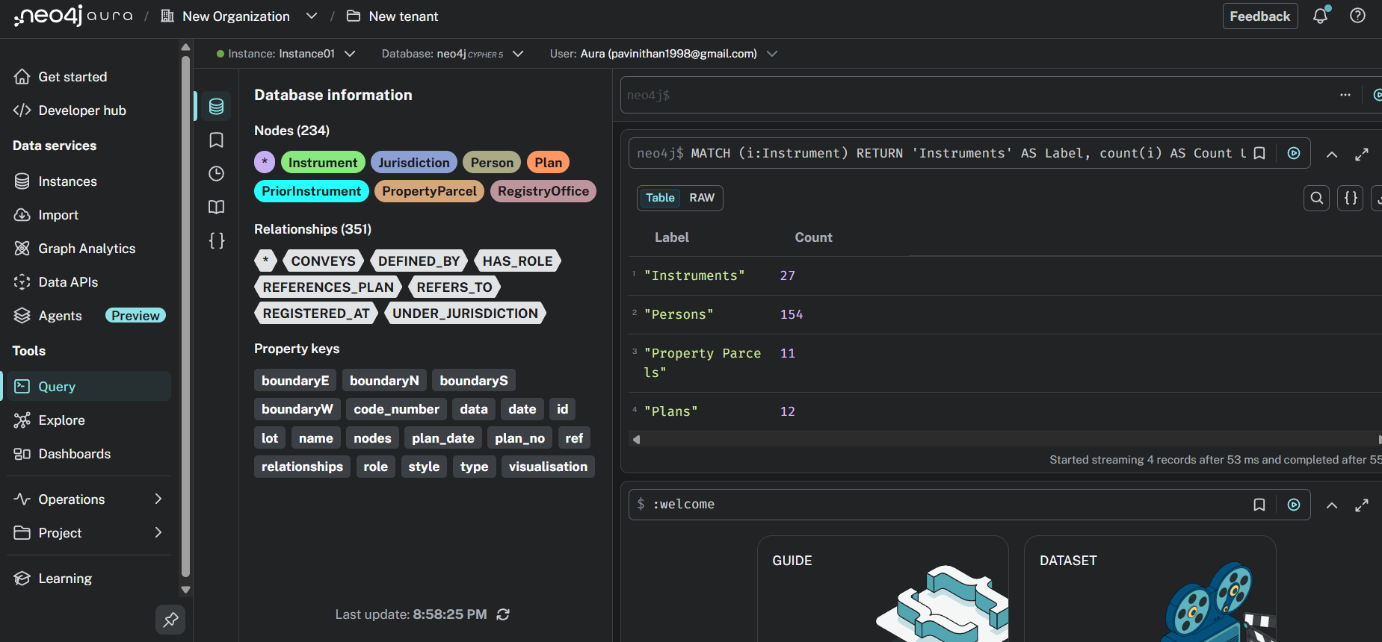
This confirms the Knowledge Graph is initialized successfully.

9. Notes for Demo
For presentation/demo:
- Open the Neo4j browser and show the graph visualization (MATCH (i)-[r]->(n) RETURN i,r,n LIMIT 20;)
- Take a screenshot of the node network and the table showing record counts.
- Explain that the KG now models entities like Instruments, Persons, Parcels, and Plans, linked through their relationships.
- This forms the foundation for the reasoning module to query and interpret relationships later.

10. Summary
Sharan’s part covers the Knowledge Graph creation, starting from raw deed extraction to uploading structured data to Neo4j Aura.
This component allows future reasoning modules to access structured legal relationships efficiently.

